**Summary of the meeting with Dr. Srinath Perera on Sept 03, 2014.**

**Important points of discussion:**

1. Initially the progress of the project was discussed under the following points were presented.

* The book Encyclopedia of chart patterns (2nd Edition) written by Thomas Bulkowski, an expertise on stock trading.
* Smoothing the data set in order to find the maximum and minimums, techniques applied;
  + Kernel Regression
  + Kalman Filter
  + Moving Averages (Exponential, double exponential, etc)

1. Considering the graphs which displayed filtered/smoothed data and row data we have to think about applying the filtering in a different way. There were some suggestions pointed out in order to proceed. Try to grasp possible techniques currently used to analyze candle stick diagrams.

I) As the filtered data have not been smoothed well with the Kalman filter and moving averages due to the high noise and volatility using the percentiles and the probabilistic approach was suggested. Such as including both the Max and Min price of the considered date and get a percentiles of the variation in order to do the smoothing.

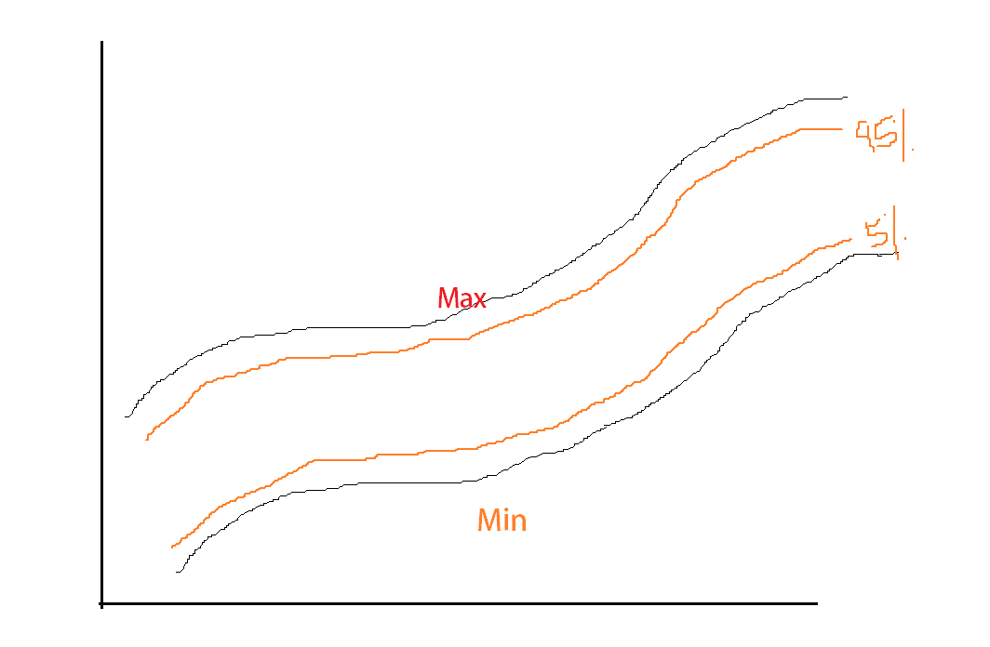

II) Boosting techniques - Combine multiple filtering/smoothing techniques together and smooth the data

1. The approaches that have been tested up to now have to be tested for a larger number of data sets, and more patterns other than triple bottom. Try to find more daily data set as well the intra data, and apply filtering to them.
2. Use the ‘**Patternz**’ software tool to find the patterns through those static data and use them as test data.
3. Compare the approaches taken with each other to find the best suitable approach. To do that we have to find a satisfactory comparing methodology. Read research papers and find comparing mechanism to compare the most suitable filtering technique.

|  |  |  |
| --- | --- | --- |
| Set of Tools + | }Compare | } Compare |
| Set of patterns |
|  |  |
| Combine Tools + | }Compare |
| Set of Patterns |

1. Reach resource person and discuss about applying signal processing techniques in our problem context.
2. Suggestion of using Machine learning algorithms to find precise parameters to smooth stock data

1. Applying the Markov Chain model on stock market data : It would add a positive impact by checking on applying it on pattern analysis. First of all get a good understand on Markov Chain model. Also check on applying Generalized Linear Model and Ridge regression on identifying patterns (Machine learning approach)

**TODO**

**Suggestions**

1. Combination (Boosting) of multiple algorithms together and compare those.
2. Rule base approach to identify extreme’s
3. Use percentile and probabilistic approach to draw chart
4. Machine learning approach to find optimum values for filters
5. Ridge Regression (Lasso, elastic net)
6. State Machine
7. Find/implement techniques to reduce the time lag
8. Compare filtering techniques

**Look more into**

* Candlestick diagrams
* Marco chain model
* Hidden Markov chain model
* Generalized Linear Model (GLM)